# Government

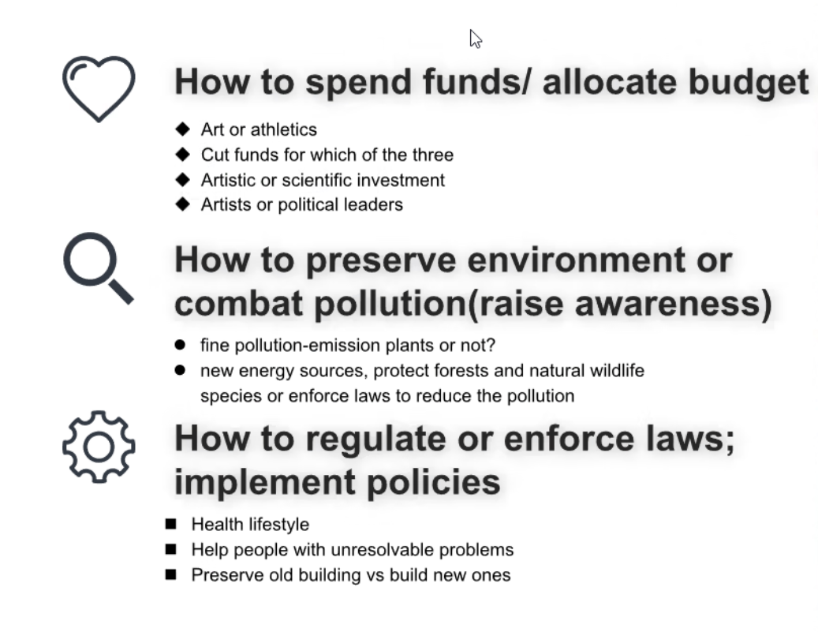

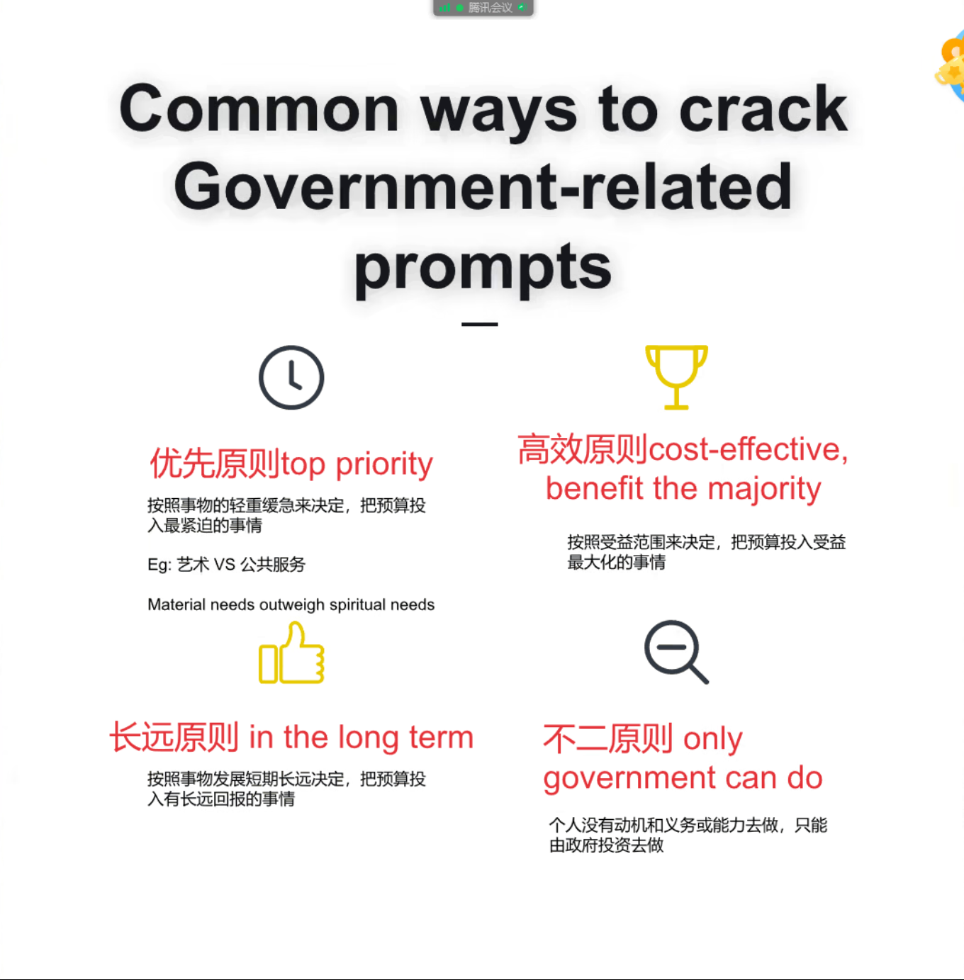

Disposable 可丢弃的，一次性的

Accountable负责/ 放心 vs responsible 简单的负责/ 责任

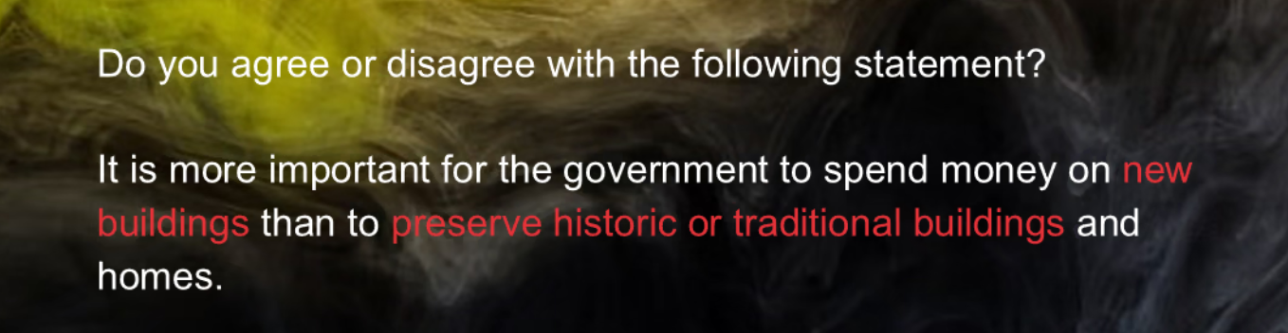

Old building

1. Maintain the local culture
2. More tourism means more government income
3. Only the government is in the best position to shoulder/ assume/ undertake the responsibility（不二原则）

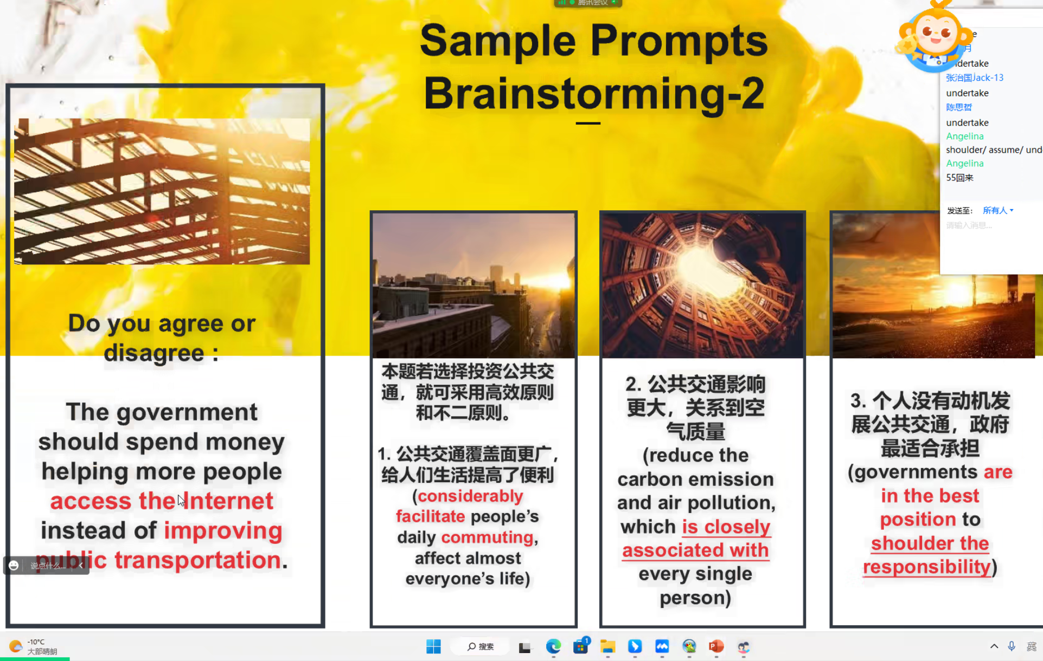

Important problems:

1. Common obligation—— compulsory education + health insurance
2. Unexpected disasters/ emergencies: earthquake, flood, natural disaster

